**Google Publishes Core Algorithm Update on July 1, 2021**

**Suggested URL:** [**https://w3era.com/google-core-algorithm-update-2021**](https://w3era.com/google-core-algorithm-update-2021)

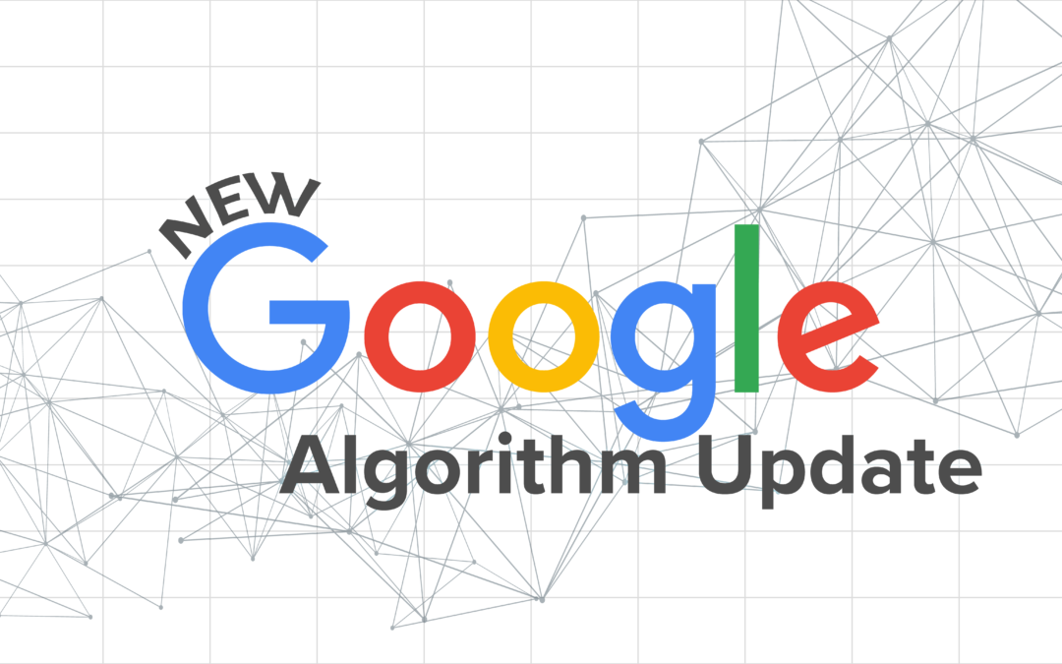

Google is publishing a widespread core algorithm update on July 1, 2021. This update was held last month and is now rolling out. It typically takes about 1-2 weeks to roll out a core update. Google’s guidance on healing from this update is the same as all other core updates launched in the past.

Free to Consult Contact Us: <https://www.w3era.com/contact-us/>

**Google's Announcement:**

Here is Google’s tweet announcing-

**“Later today, we are releasing a broad core update, as we do several times per year. It is called the June 2021 Core Update.”**

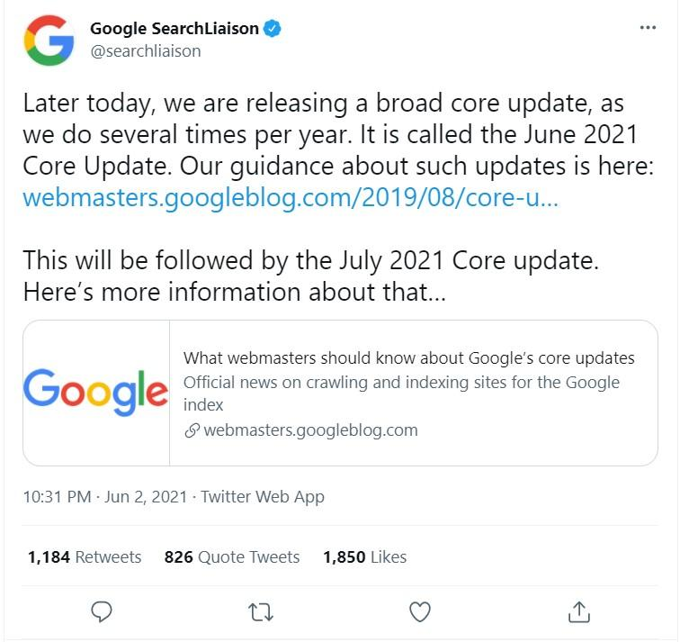

**Effect and Analysis of the Google Core Update 2021**

Searchmetrics founder and chief innovation officer, Marcus Tober, analyzed the data also practiced a more intimate look at the winners and losers, and the trends behind them.

* **Why does Google publish 2 core updates?**

Let's review why Google is launching two different core updates one month after the next?

[Google](https://www.w3era.com/) informed that some of the organization's outlined corrections for the June 2021 update are just not fully ready to be published this month. So Google decided to proceed forward with the parts that are ready now, and the rest will be driven out next month in the July 2021 core update. Google will post when that July 2021 core update is released. Any core update can generate drops or gains for some content. Since by releasing these two parts of the view, a very small part of the content might see variances in June that are modified in July.

* **What You Should Expect?**

As with most general core updates, Google is presenting somewhat mixed signals about how big the effect will be.

The organization says most sites won’t notice any variations to their presence in search results. At the same time, Google announces the update will appear “some widely noticeable effects.” This update is majorly recovery for site owners who connected months ago.

Probably, for some site owners, this is the improvement they’ve been expecting for. After being negatively influenced by a Google core algorithm update, it may take until the next core update before noticing any significant signs of recovery.



**Summing-Up:**

3 Points now about the [June 2021 Core Update](https://developers.google.com/search/blog/2019/08/core-updates)**-**

1. The first Core Update in 2021 resembles a summer blockbuster in two parts. The first update was rolled out in June, the second is released in July.
2. Winners usually include more experienced, large websites that have been missing visibility for many years. Many winners suffered losses in former Core Updates. On the other hand, losers include many YMYL sites and segments.
3. The premise is that Google’s June update may have given too much influence to some classic [SEO](https://www.w3era.com/local-seo-services/) factors, domain age, and backlinks. Google has modified earlier Core Updates parts and intends to correct these mistakes in the consequent July update. Google has shown out that some sites might recognize some of the changes from the June update changed in the second part of the update in July.

For More Latest Google Updates Visit Here: <https://www.w3era.com/blog/>

**Vinita Choubisa**

**(Digital Marketing Executive)**